Final Report

Game Development Project

sean khanna – Q11279516

Level 6

Contents

What went right and what went wrong? 2

Right 2

Wrong 2

Improvements 2

References 3

Appendix 4

Appendix A – HacknPlan 4

Appendix A.1 – HacknPlan Backlog 4

Appendix B – GitHub 5

Appendix C – Black Box Testing 5

Appendix D – White Box Testing 5

* Somewhere talk about why this would be good for kids with disabilities etc

# Does the product meet the set goals and objectives?

## Process used to verify goal completion

## Why some goals might not have been met?

### What I could do next time to complete those goals

### If I was to do it again what changes to my schedule would I make

# What went right and what went wrong?

## Right

## Wrong

## Improvements

# Improvements made by request (with proof)

# What I am going to do with the project in the future

* Areas of improvement

# What did I learn

# What could I have done differently during development

# References

# Appendix

## Appendix A – HacknPlan

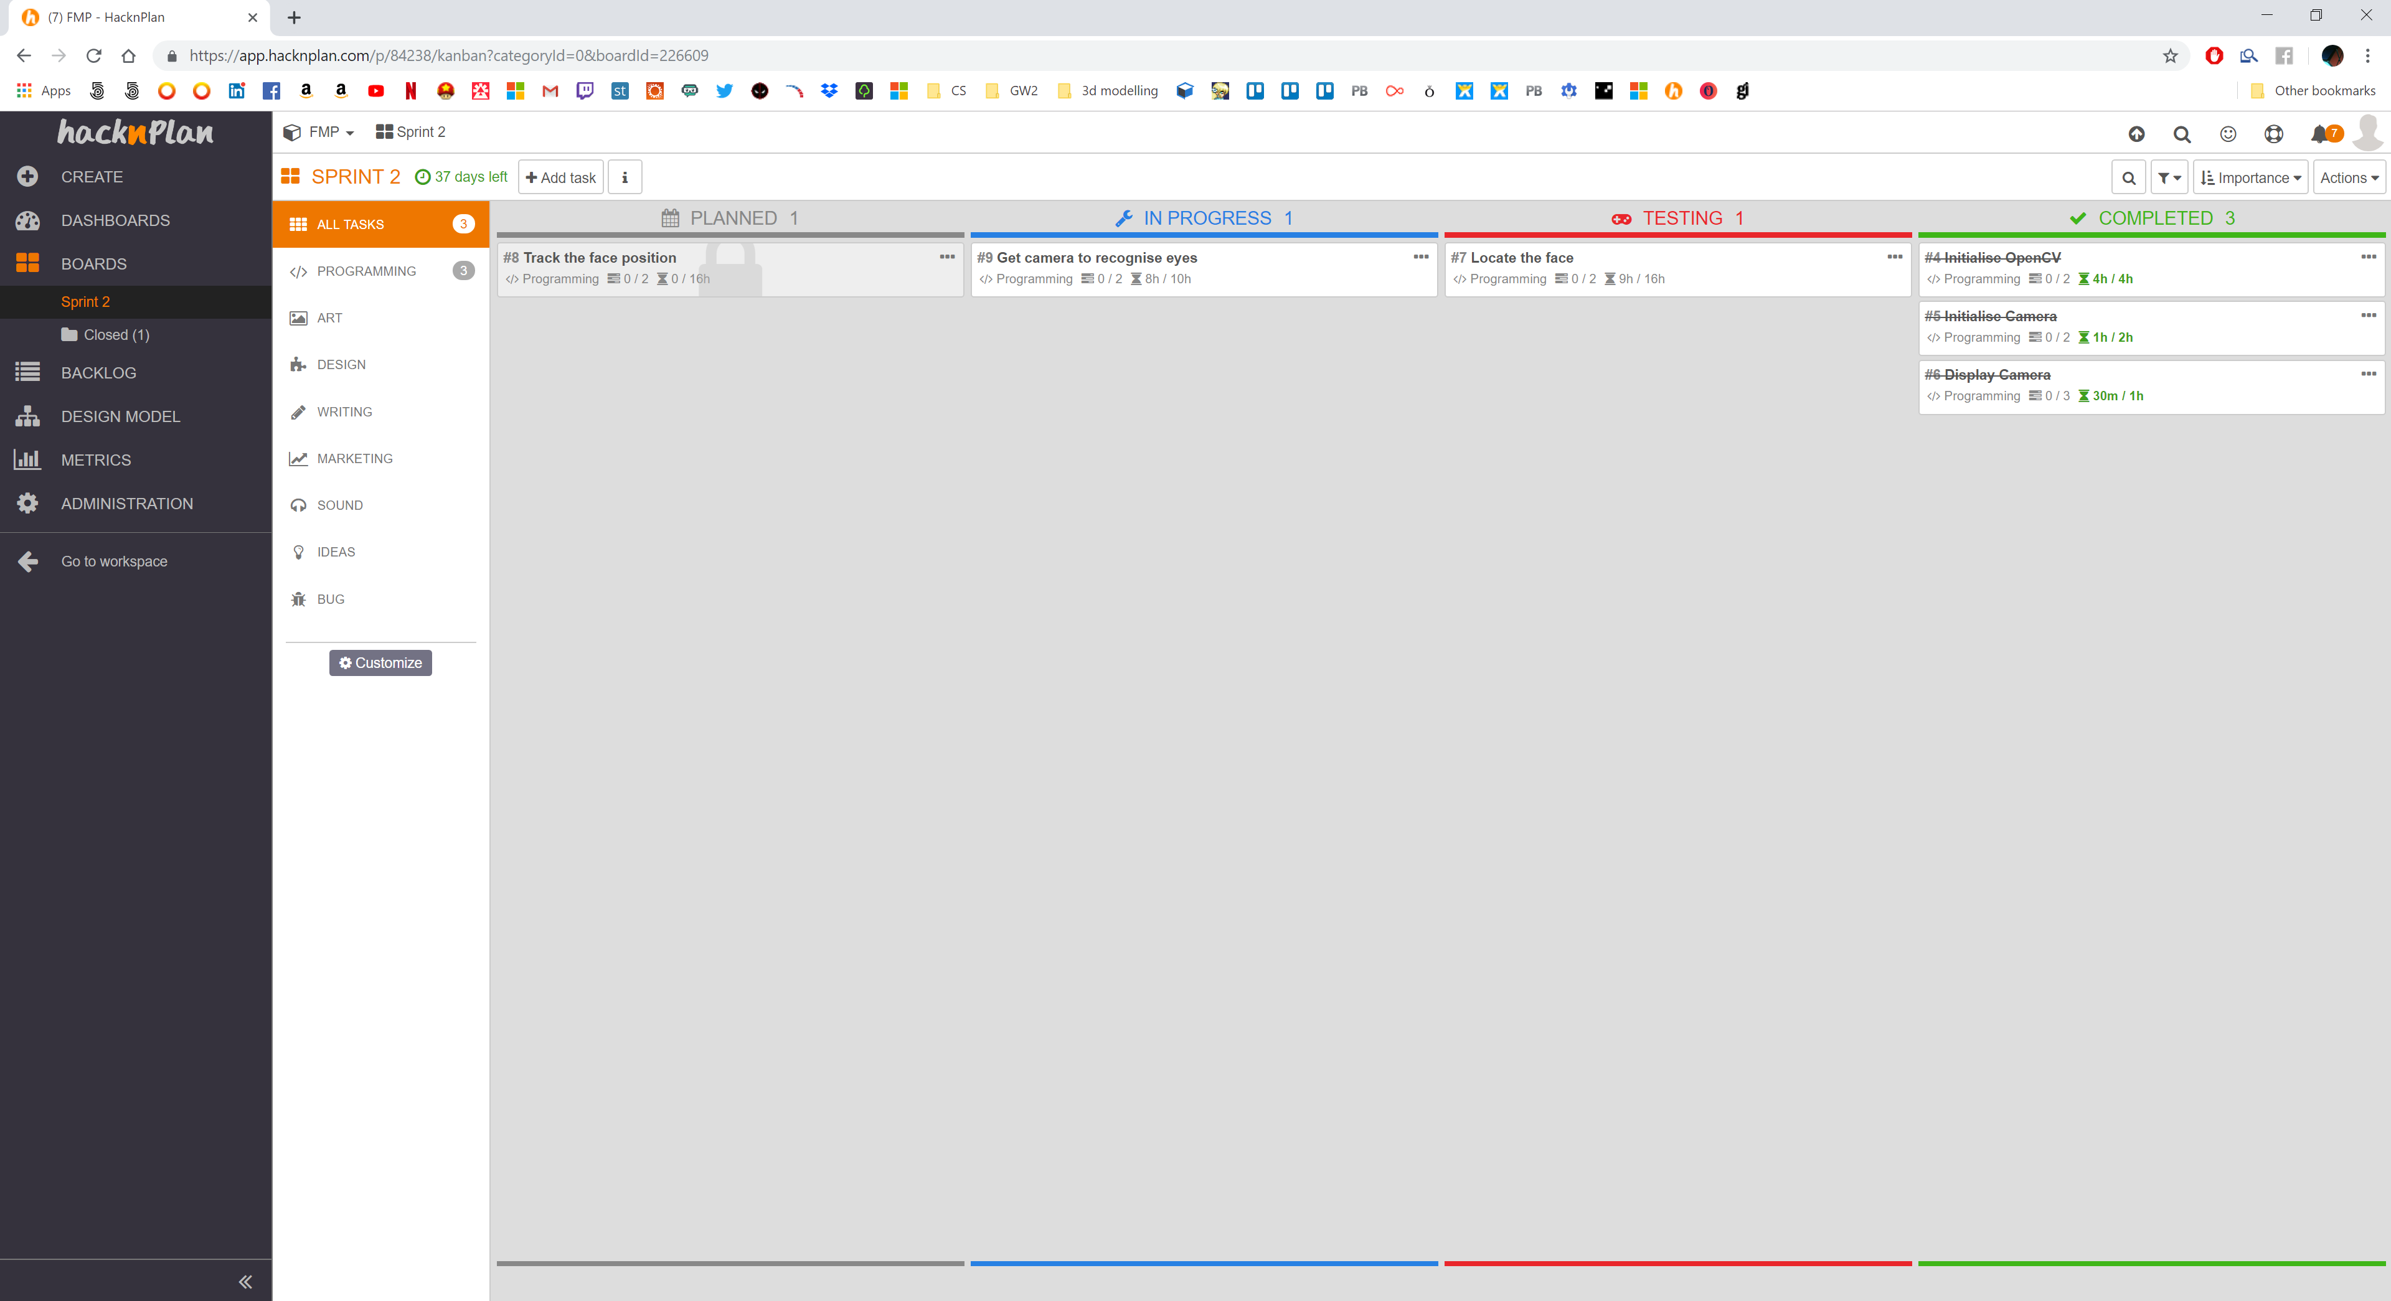

### Appendix A.1 – HacknPlan Backlog

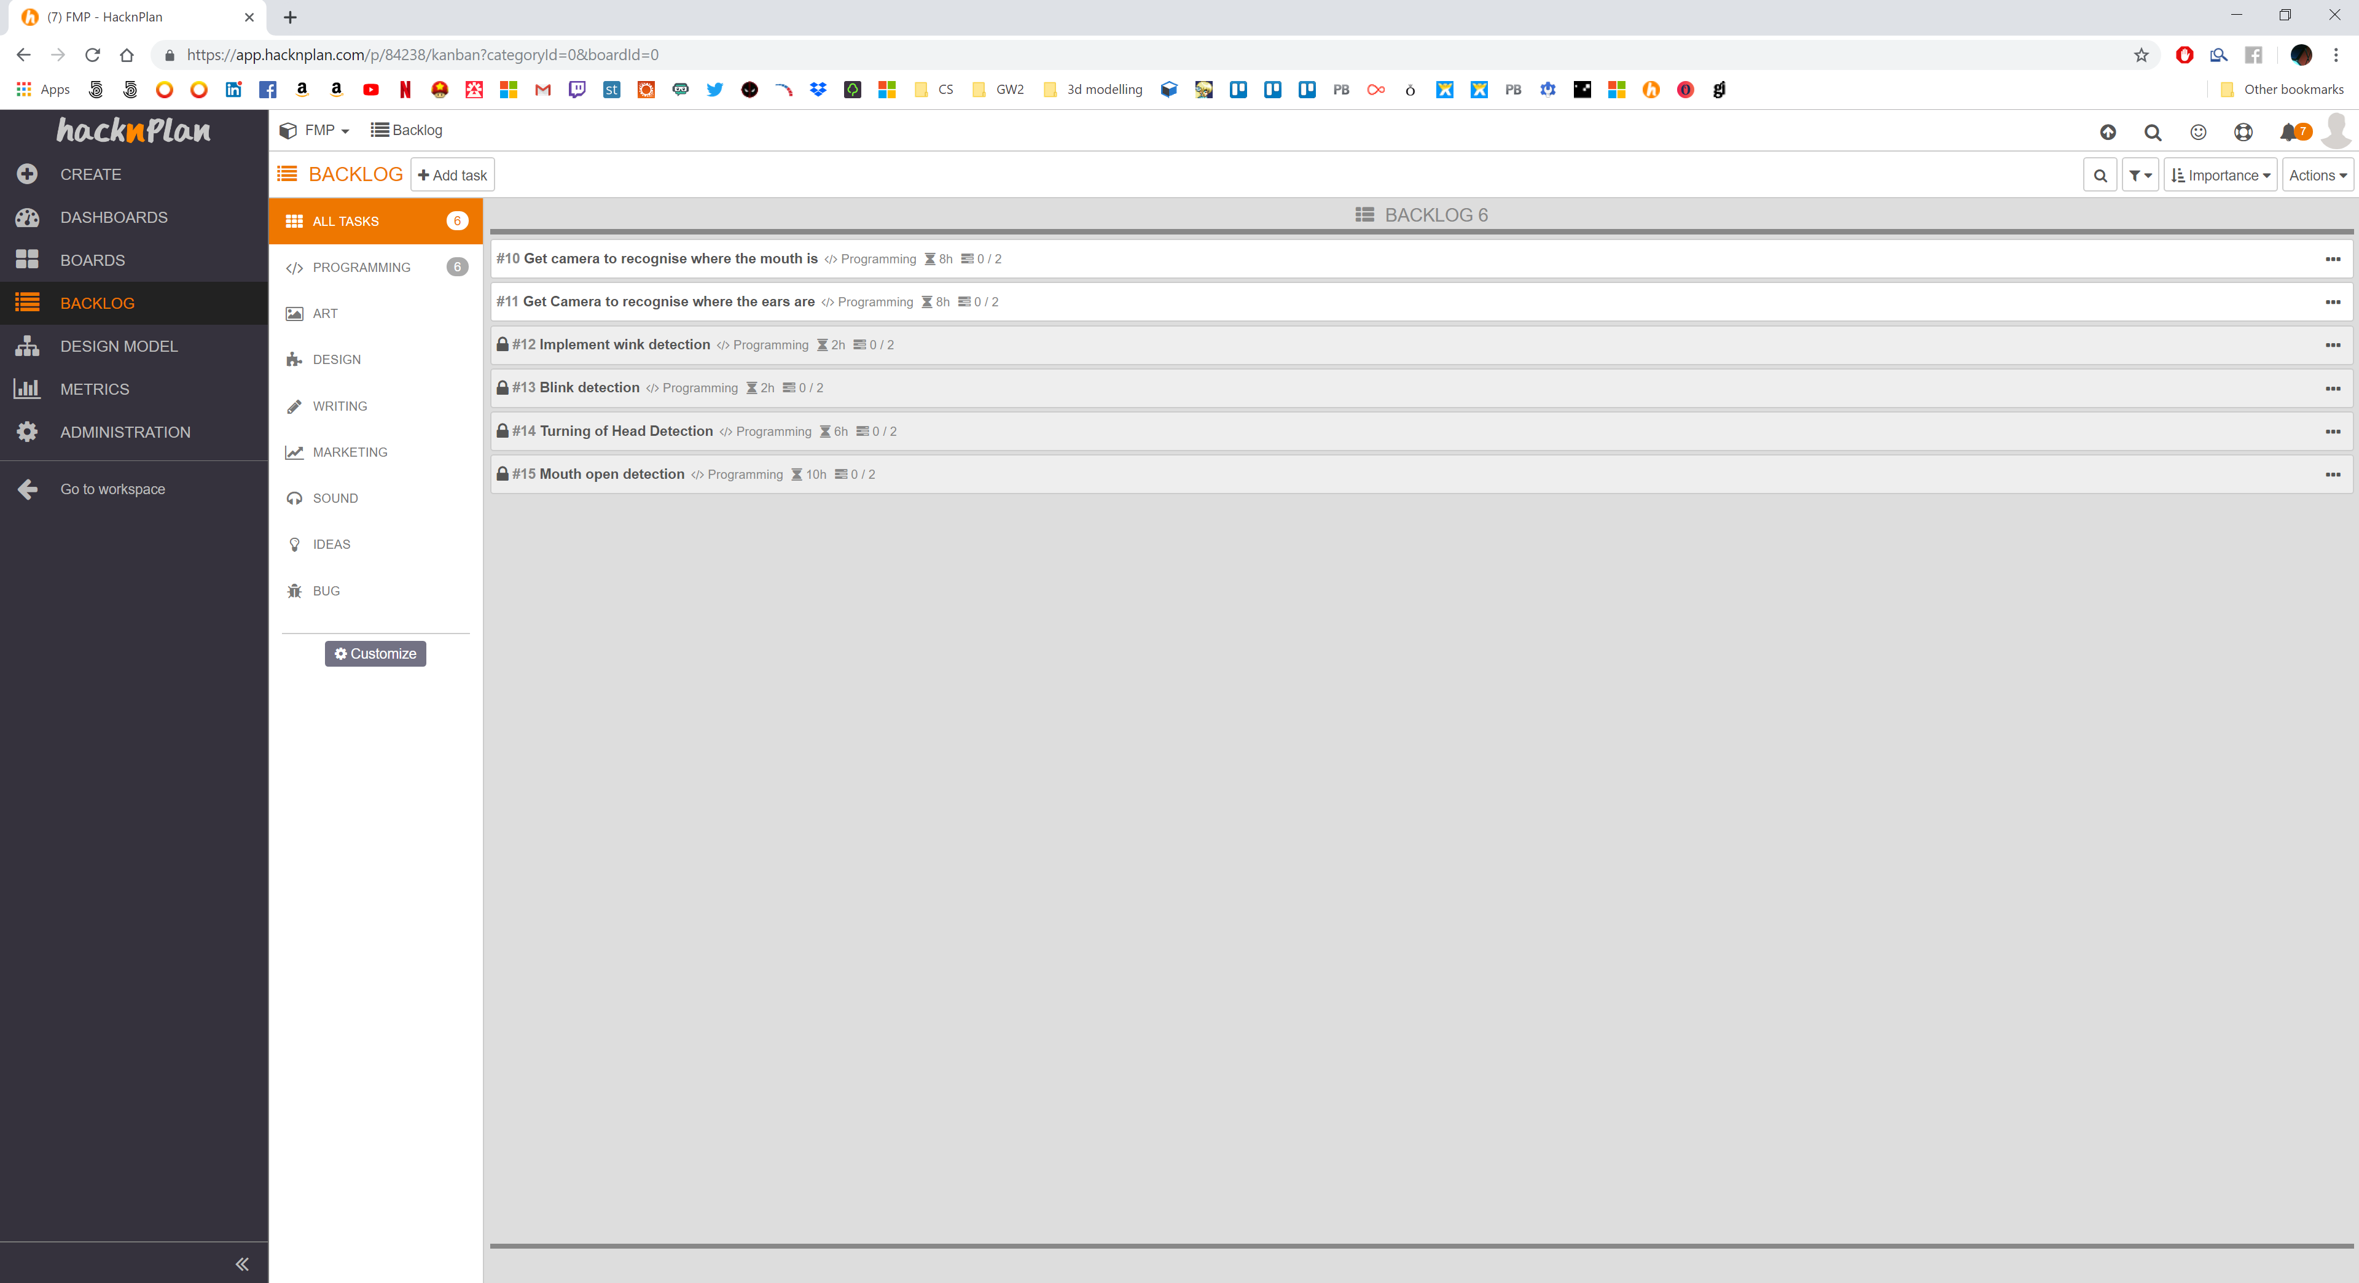

## Appendix B – GitHub

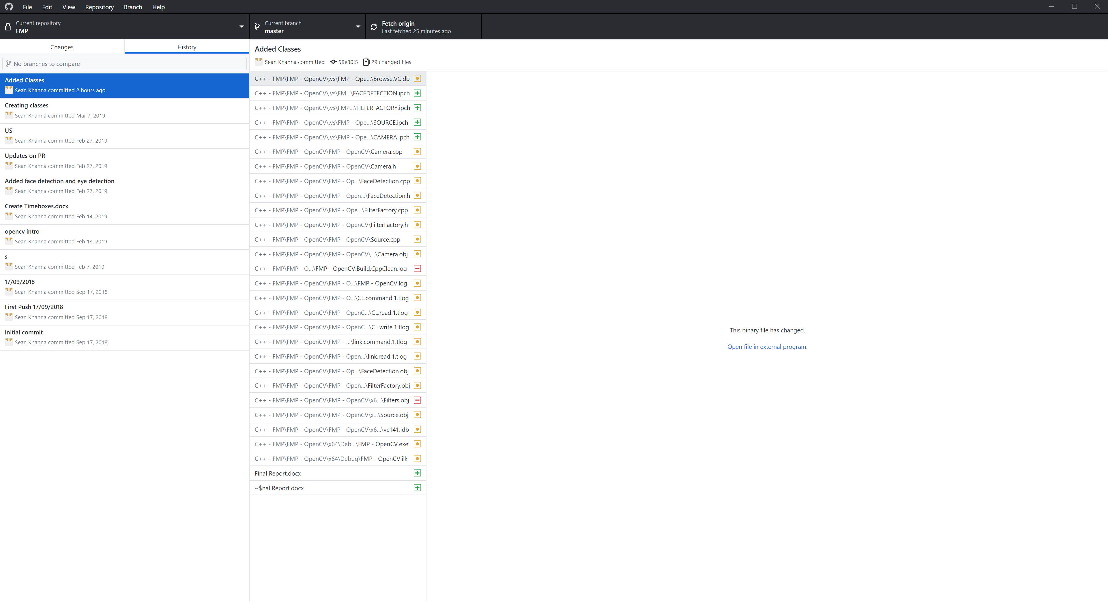

## Appendix C – Black Box Testing

|  |  |  |  |  |  |
| --- | --- | --- | --- | --- | --- |
| Test ID | Feature | Test | Expected | Actual | Solution |
|  |  |  |  |  |  |
|  |  |  |  |  |  |
|  |  |  |  |  |  |
|  |  |  |  |  |  |
|  |  |  |  |  |  |
|  |  |  |  |  |  |
|  |  |  |  |  |  |

## Appendix D – White Box Testing

|  |  |  |  |  |  |
| --- | --- | --- | --- | --- | --- |
|  |  |  |  |  |  |
|  |  |  |  |  |  |
|  |  |  |  |  |  |
|  |  |  |  |  |  |
|  |  |  |  |  |  |